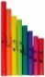

G
G
E
E
C
E
C

B
B
G
D
F
D
F

G
G
E
E
C
E
C

FISZ
FISZ
G
G
C
C

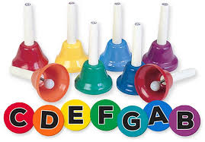
G
G
E
E
C
E
C

B
B
G
D
F
D
F

G
G
E
E
C
E
C

FISZ
FISZ
G
G
C
C

G
G
E
E
C
E
C

B
B
G
D
F
D
F

G
G
E
E
C
E
C

FISZ
FISZ
G
G
C
C

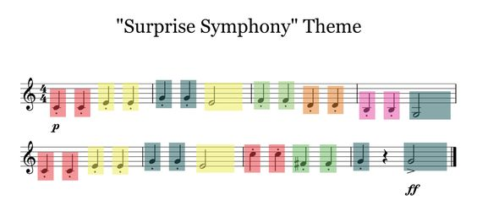
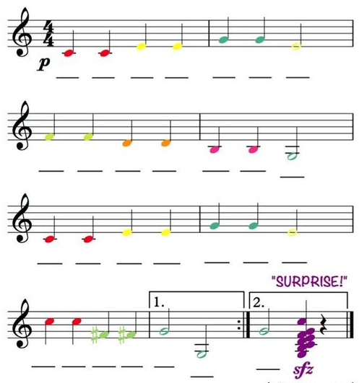
Forrás: https://i.pinimg.com/originals/64/22/fa/6422fa0d8d1b57bb54b9ae5109f670f8.jpg

Oktató videók:
(Adagio): https://www.youtube.com/watch?v=6a8anQe7zq8&ab_channel=Twenty-SecondCenturyMusic%2CLLC
https://www.youtube.com/watch?app=desktop&v=83V977ByigQ&ab_channel=Twenty-SecondCenturyMusic%2CLLC

Andante: https://www.youtube.com/watch?v=aZ4MwIdHboQ&ab_channel=Twenty-SecondCenturyMusic%2CLLC
https://www.youtube.com/watch?v=Fyj4Lmvtqok&ab_channel=HahaMusicEducation
https://www.youtube.com/watch?v=Nup3rxRs35Y&ab_channel=AudMaritLarsen

Ritmusgyakorlatok: https://www.youtube.com/watch?v=J_jGAnUmuTU&ab_channel=No%C3%A9Blanco
https://www.youtube.com/watch?v=4Tqg9piwo_k&ab_channel=HahaMusicEducationhttps://www.youtube.com/watch?v=4Tqg9piwo_k&ab_channel=HahaMusicEducation
https://www.youtube.com/watch?v=4Tqg9piwo_k&t=13s&ab_channel=HahaMusicEducation

Oktató videó félhangokkal: https://www.youtube.com/watch?v=Fyj4Lmvtqok&ab_channel=HahaMusicEducation

