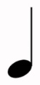=
=
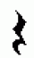=
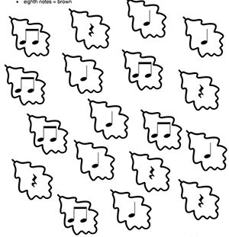
Kép forrása: https://www.bethsnotesplus.com/2017/09/leaf-pumpkin-note-handouts.html

